Optimizing SOA to Support e-Learning with Adaptive and Intelligent Features

Intelligent Features

3/9/2010

Faculty of Computers and Information Sciences, Mansoura University, Egypt

Haitham A. El-Ghareeb

Table of Contents

Intelligent Feature 1: Intelligent Recommender 1

1. Workflow Diagram 1

2. Composing Services 2

2.1 Learning Profiles Manager 2

2.2 Learning Objects Manager 6

2.3 Suggested Modification to SCORM Classification View 13

Intelligent Feature 2: Intelligent Calendar Services 14

1. Workflow Diagram 14

# Intelligent Feature 1: Intelligent Recommender

**Objectives and Specifications:** Generate student’s specific recommended Learning Objects (LOs) list based on their learning preferences that satisfies the learning objectives of one of the learning topics. Learning objectives are identified by “keywords”. Generated list is enhanced by instructors to fine tune system’s performance.

* **Input**

1. Student Profile and Learning Preferences (W*i*)
2. LO’s Specifications (W*j*)
3. Course Specifications and Keywords (W*k*)
4. Instructor Updates (W*l*)

* **Processing**
  + Utilized Intelligent Techniques:
* **Output**
  + Personalized Recommended LOs List
* **Feedback**
  + Student Updates LOs Rank. Ranking is stored and affects LO’s Specifications (W*j*)

## Workflow Diagram



Figure 1: Intelligent LOs Recommender Workflow Diagram

## Composing Services

Composing Services can be categorized into: Pedagogical and Managerial services. Focus here is on Pedagogical Services.

### Learning Profiles Manager

Three different learning profiles will be available for each student:

1. General
2. Felder
3. ATLAS
4. Brain Works

#### General Learning Profile Manager

During registration and profile completion process, students are asked to complete their general learning preferences features. Incase student chooses more than one style, s/he is asked to rank her/his choice, so recommendation can define to what extent it is fulfilling student’s requirements. General Learning Profile Preferences are:

* Visual
* Auditory
* Tactile
* Logical
* Social
* Solitary



Figure 2: General Learning Profile Manager DB Tables

**Consumed Services:** Students Manager

#### Felder Learning Model

Felder learning model can be identified by promoting student to answer questions that help identify students’ learning preferences. Though Felder identifies that student is middle between different models, Felder model can help system identify student learning features, and prepare the most appropriate learning environment. Felder learning model categories are:

* Active and Reflective
* Sensing and Intuitive
* Visual and Verbal
* Sequential and Global



Figure 3: Felder Learning Model DB Tables

**Consumed Modules:** Calculate FelderCategoryRelevance

**Consumed Services:** Students Manager

#### ATLAS Learning Model

ATLAS learning model can be identified by promoting student to answer questions that help identify students’ learning preferences. ATLAS learning model categories are:

* Navigator
* Problem Solver
* Engager



Figure 4: ATLAS Learning Model DB Tables

**Consumed Modules:** Calculate ATLASCategoryRelevance

**Consumed Services:** Students Manager

#### Brain Works Learning Model

Brain Works learning model can be identified by promoting student to answer questions that help identify students’ learning preferences. Brain Works learning model categories are:

* Visual vs. Auditory
* Left vs. Right Brain Hemisphere



Figure 5: Brain Works Learning Model DB Tables

**Consumed Modules:** Calculate BrainWorksCategoryRelevance

**Consumed Services:** Students Manager

### Learning Objects Manager

Figure 6 presents an overall DB Tables structure of LO using SCROM 2004 Standard. Based on the SCORM 2004 Standard, LO can be viewed from different perspectives; each perspective is the collection of appropriate tables that will be presented in proposed system as specific view:

* Classification
* Educational
* General
* Lifecycle
* Meta-Metadata
* Other
* Technical

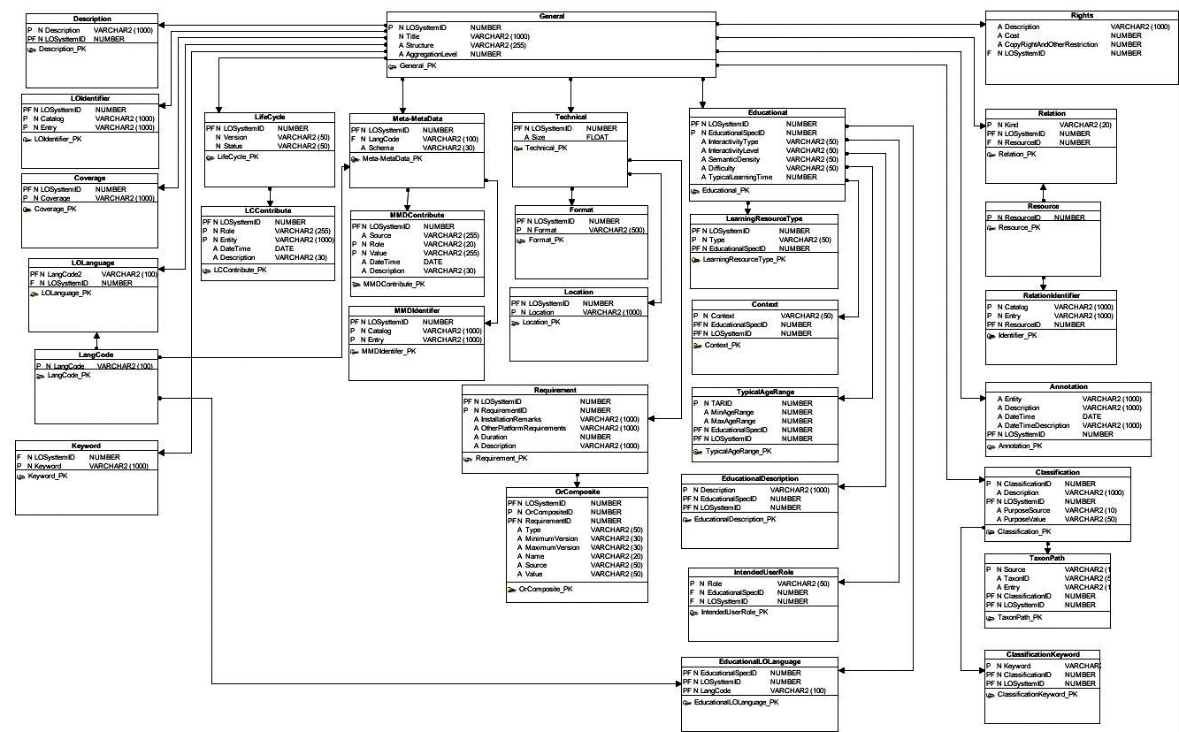

Figure 6: SCORM 2004 Overall DB Tables Structure

#### Classification



Figure 7: SCORM - Classification View

* + 1. ***Educational***



Figure 8: SCORM - Educational View

#### General



Figure 9: SCORM - General View

#### Lifecycle



Figure 10: SCORM - Lifecycle View

#### Meta-Metadata



Figure 11: SCORM - Meta-Metadata View

#### Other



Figure 12: SCORM - Other View

#### Technical



Figure 13: SCORM - Technical View

### Suggested Modification to SCORM Classification View

An added value that represents relationship between LO and Keyword can be added. This value might represent (Fuzzy Logic) function, or act as (Weight).

# Intelligent Feature 2: Intelligent Calendar Services

## Workflow Diagram



Figure 14: Intelligent Meeting Time Arranger Service Data Flow Diagram

# Intelligent Feature 3: Calculate Time for Learning

Time to Learn is not the same with all students. It differs from student to another based on personal features of that student. Time Calculation process starts with the time defined by instructors as default, then tracking of student progress regarding this time is important. Shift from defined time (either decrease or increase) can happen. By tracking and recording that shift, it will be used to generate difference between student time and identified time. The newly generated time will be used in the (Agenda) functions. Study time can be affected by: Scheduling of examinations and other assignments.

**Intelligence**: Different weights between (Time defined by instructor, times consumed before by students who studied the same topics, and shift delay/enhancement of the same student for previous topics).

# Intelligent Feature 4: Agenda

Agenda will not be utilized in defining time tables and meeting times, it is a part of a complete (Time Management Solution) based on student preferences. Student preferences can include: preferred weekends, preferred study times, and it automatically acquires time required to study a certain topic from (Calculate Time for Learning) and it starts mapping this time on the (Agenda) to the spare time. Thus, issues like (not enough time) and (extra wasted time) can be identified. By this way, we can enhance students’ lives by engaging them in more activities. By managing their agendas and opening new opportunities to them, we can manage that in day [] of month [] there will be a sports activity day, so we will not force students to just study. We can help planning their study.

**Intelligence**: Priorities of different activities (different weights), Different Constraints [This is a typical Optimization Problem].

# Intelligent Feature 5: Study Plan

Study plans shall consider: Instructor Recommendations, Previous Students attended, and Current Students preferences. Learning topics will not differ in content; they can differ in order within a certain framework identified by instructor. Tracking student study behavior is important. It is a well-known problem for instructors that they can’t record students’ study behavior because students can’t define time consumed for activities. Study activities include: group meetings, buying textbooks, meeting with the instructor or other members of the class, reviewing notes, doing reading or writing assignments. the two available methods are: ask students at the end of the course how much hours they have spent studying weekly, or ask students to record the study hours and activities while they are doing it. Both methods are not reliable. Proposed system can track times for different activities without bothering students.

# Intelligent Feature 6: Generate LVQ Questions based on Learning Preferences

We have learned from reading different learning preferences that: MCQ for example is not the appropriate type of question to be used to test all types of learners. Intelligently generating assessments (via taking in consideration: student’s class, difficulty of question, type of question, relevance of question to tested learning topic) is important.

Intelligence: